TECHNICAL PROJECT REPORT

# Title of Invention / Project:

# cnc machine

# Team Members / Inventors:

|  |  |  |  |  |  |
| --- | --- | --- | --- | --- | --- |
| **S.No.** | **Name** | **Department** | **Designation** | **Mobile** | **E-Mail** |
| 1. | Tarun Pundir | ECE | Student | 9027969217 | tarun.pundir111@gmail.com |
| 2. | Hima Bisht | ECE | Student | 8054357080 | bishthimani8054@gmail.com |
| 3. | Khushal Thakur | ECE | Mentor | 9646030764 | khushal.thakur@cumail.in |
| 4. | Anshul Sharma | ECE | Mentor | 9478697475 | anshulsharma.ece@cumail.in |
| 5. | Kiran Jot Singh | ECE | Mentor | 9463909689 | kiranjotsingh.ece@cumal.in |
| 6. | Divneet Singh Kapoor | ECE | Mentor | 9878422653 | divneet.ece@cumail.in |

Section – 1 (IPR Related)

# Brief Abstract (500 words):

* Problem your project is solving.
* A CNC machine or computer numeric machine is designed to control various machinery functions using computer programs. In this project , the machine is made such that the code made for it can be used to draw the outcome of that code .This concept is used to make logos, drawings and other artwork in a real less time. Portraits and sketches can be made like as of an artist's masterpiece.
* How are you solving that (solution)?
* All we have to do is make a code of that picture. Yes! So what we are basically doing in this project is that firstly, we need a picture in pnp. or jpeg. form and that picture's outline is converted into g-code (this can be done with the help of various apps that offers to do so). So the g-code is basically a program that will be used to run the CNC machine to draw that code's picture. We have already prepared some g- codes for our CNC machine , which includes outline of a tattoo. We are using plain white sheets as a screen where the pen inserted in machine can draw. The movement of this pen is controlled by the motors used for X, Y and Z axis (where these axis are instructed through the G- code). We are using 8mm motor for X and Y axis and one servo motor for Z axis.
* Additional modifications that can cater to improved solution.
* The area for improvement can be the size of the portrait which we make. For that more powerful motors will be required. Also, we can find a solution for efficiency of the machine i.e. it would complete the drawing in less time . The last idea is to develop more and more g-codes in less time so that any virtual photograph's outline can be drawn with an instant.

# Existing state-of-the-art and Drawbacks in existing state-of-the-art

(*Brief background of the existing knowledge*)

|  |  |  |
| --- | --- | --- |
| **S. No.** | **Existing state of art** | **Drawbacks in existing state of art** |
| 1 | <https://patents.google.com/patent/US8195310B2/en> | 1. If the program posses even a single error ,then retracing and correcting that will be difficult . Also description of the project is way too long and confusing . |
| 2 | <https://patents.google.com/patent/US7398717> | 2.The objects to be cut need to be moved manually to increase efficiency. |

# Novel/Additional modifications that you can propose to improve upon drawbacks

*(List down the features)*

* To increase the size of final image to be drawn. More Powerful motors required
* Develop more g-codes in lesser time.

# Advantages

* The bigger image means better resolutions and clarity which will look more attractive.
* More g codes in lesser times means increase efficiency of the machine.

# Block Diagram

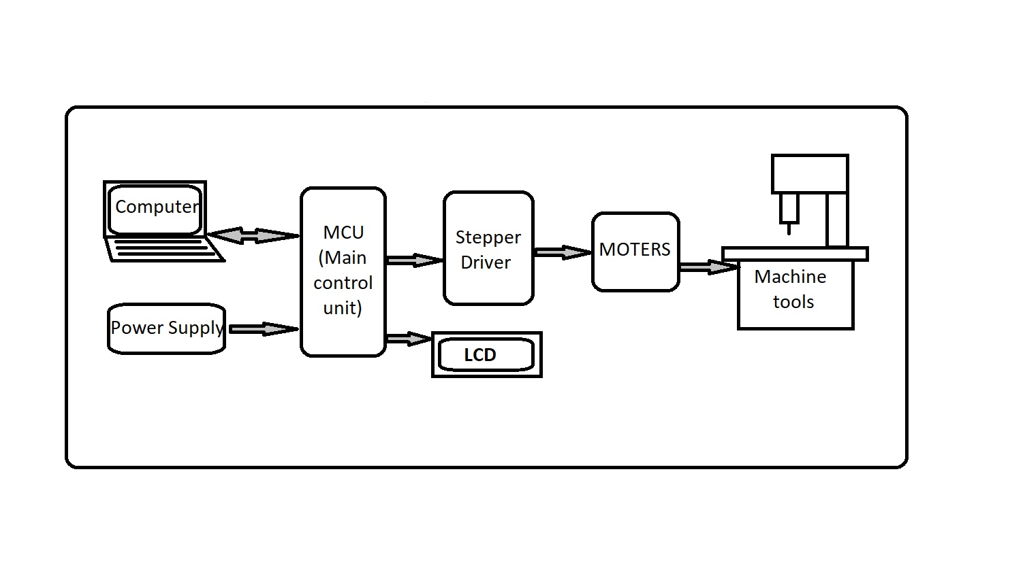

Section – 2 (Real Project)

# Materials

|  |  |  |  |
| --- | --- | --- | --- |
| S.NO | Product Name | Quantity | Price |

|  |  |  |  |
| --- | --- | --- | --- |
| 1. | Arduino Nano | 1 | 300**₹** |
| 2. | L293D (IC) | 2 | 100**₹** |
| 3. | IC BASE | 2 | 20**₹** |
| 4. | Servo Motor (SG90) | 1 | 150**₹** |
| 5. | Stepper Motor | 2 | 200**₹** |
| 6. | 4 pin relimate connector female | 2 | 20**₹** |
| 7. | 4 pin relimate connector male | 2 | 20**₹** |
| 8. | PCB (3*5) | 1 | 30**₹** |
| 9. | Small Wire roll | 1 | 25**₹** |
| 10. | CPU DVD Writer | 2 | 200**₹** |
| 11. | Wooden board | 2 | 100**₹** |
| 12. | Header connector | 2 | 20**₹** |
| 13. | Solder wire | 1 | 80**₹** |
| 14. | Solder flux | 1 | 10**₹** |

# Circuit Diagram

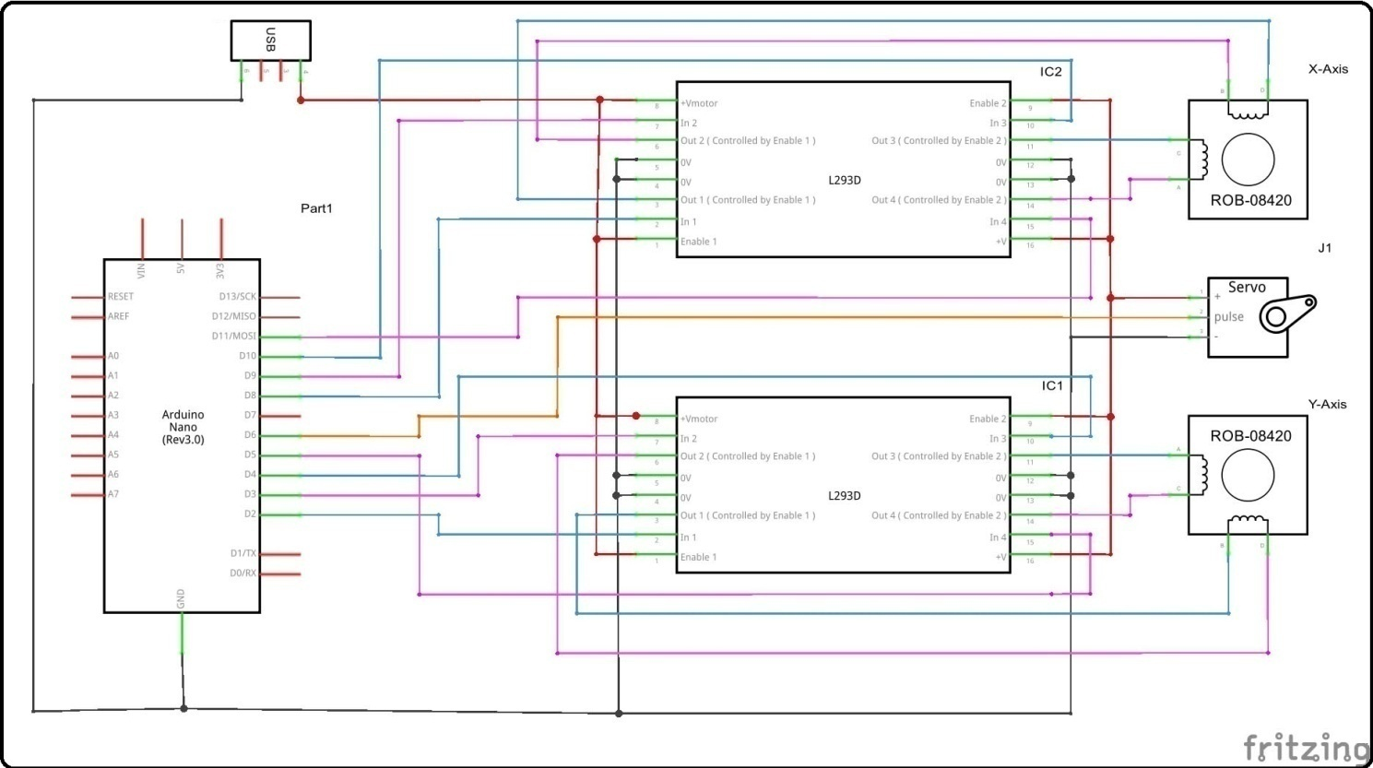

# Steps of Circuit Completion

STEP 1. I will connect all the connectors in the PCB.

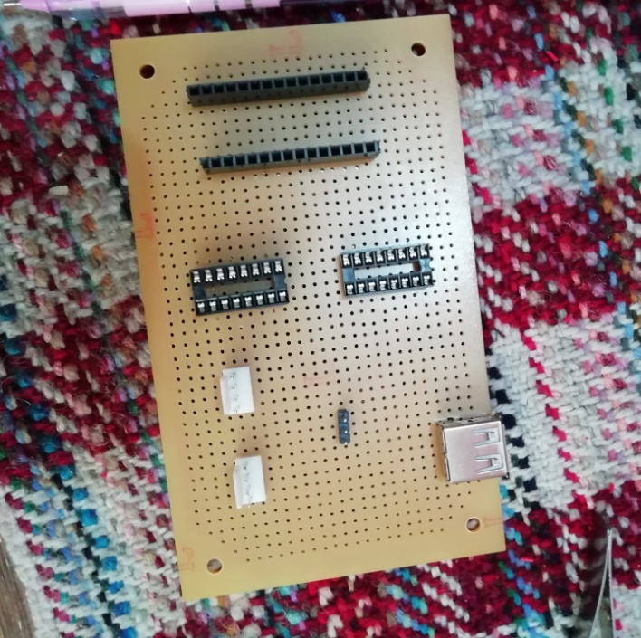

STEP 2. I Soldered all the connectors in a PCB.

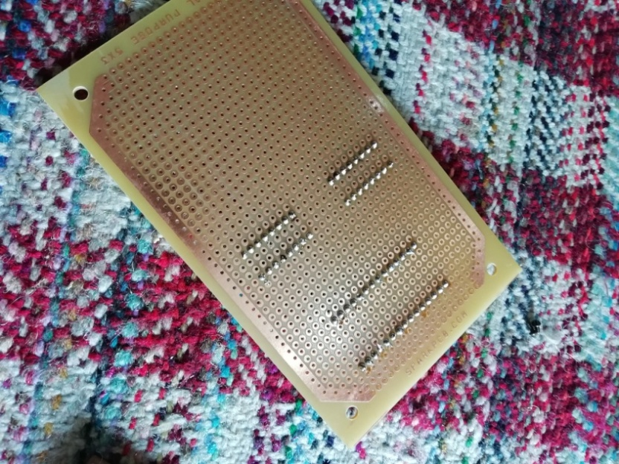

STEP 3. I connect D2,D3,D4,D5 Pin of Arduino to Pin no 2,7,10,15 of IC1 And connect D8,D9,D10,D11 pin of Arduino to pin no 2,7,10,15 of IC2 .

STEP4. Connect pin no 1, 8, 9, 16 of both IC to the +5V DC (Means connect the positive pin of USB.

STEP5. Connect pin no 4, 5, 12, 13 of both IC to the Ground pin of IC and Arduino.

STEP6. Connect D6 pin of Arduino to Servo signal pin.

STEP7. Connect the servo +ve and –ve wire to the USB +ve & -ve pin.

STEP8. Solder the stepper Motor with connector wire.

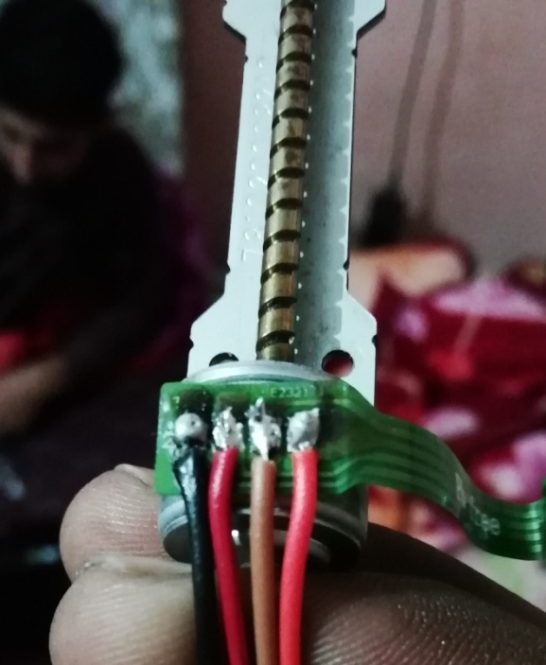

STEP9. Connect (IC1) Pin no 3 & 6 to stepper B & D and Pin no 11 & 14 to A & C.

STEP10. Connect (IC2) Pin no 3 & 6 to stepper D & B and Pin no 11 & 14 to C & A.

STEP11. Check all the wiring is correct and test the circuit.

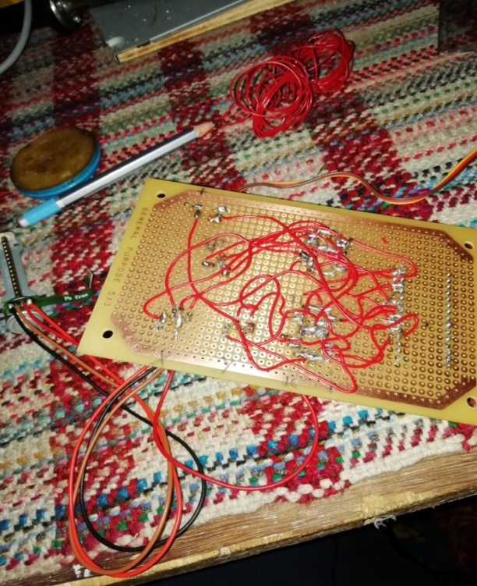

Program Code:

* <https://github.com/TarunPundir/CNC-Machine>